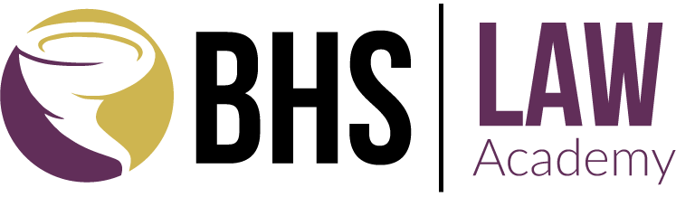
BOOKER HIGH SCHOOL
2022-2023 APPLICATION RECOMMENDATION FORM

Please have one of your teachers or counselors complete the following recommendation for and return with your Application for Admission - both are required for applications.

Please return to: ryan.kelley@sarasotacountyschools.net or

Booker High School
Attn: Ryan Kelley, Law Academy Coordinator
3201 N. Orange Avenue
Sarasota, FL 34234
941-355-2967, ext. 65178

Student Name ________________________________________________________________________

Teacher/Counselor ___________________________________________________________________

Teacher/Counselor Phone or Email _____________________________________________________

Please identify any three qualities of the student you think are valuable to his/her success: ________________________________________________________________________________________________________________________________________________________________________________________________________________________________________________________________________________________________________________________________________________________________________

Do you have any reservations about recommending the student for Booker High School Law Academy? If yes, please explain. ________________________________________________________________________________________________________________________________________________________________________________________________________________________________________________________________________________________________________________________________________________________________________
Teacher / Counselor Signature __________________________________________ Date ____________

